Updating Leave Accrual Balances

- Navigate to Employee Management -> Employee Benefits -> Accruals -> Leave Accruals and select the employee whose balance you would like to update.
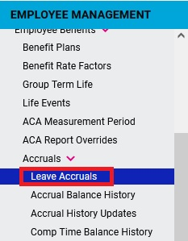
- Enter the desired Ending Balance in the Update Balance box for the appropriate plan. The figure in the Update Balance box will be the ending balance following the next payroll processing. So the figured entered needs to also include any time accrued on the current pay period and also be reduced by any time taken on the current pay period or lost to carryover.
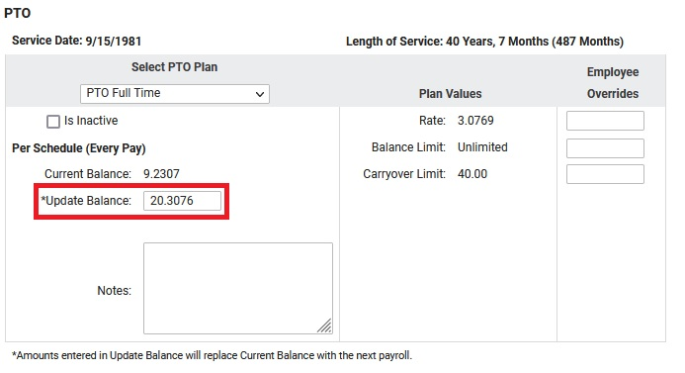
In the example shown above, we are trying to add 8 hours to the employee’s PTO balance but because the Update Balance box will be the ending balance following the next payroll, we need to also include the amount they would accrue on the upcoming payroll so our formula is:
9.2307 (Current Balance) + 8 (Hours Being Added) + 3.0769 (Hours Accrued On This Payroll) which equals 20.3076.

