How to Manage the Pending Employee Dashboard

- Navigate to Employee Admin Tools -> Employee Administration -> Pending Employees.
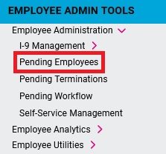
- Under the Status column, you will see one of two statuses:
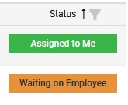
  - Assigned to Me - The employee has completed the onboarding wizard and is ready for you to finalize onboarding.
  - Waiting on Employee - The employee has not completed the onboarding wizard yet.
- Under the Actions column, click on the ellipsis (…) next to an employee’s name. You will be presented with a few options:
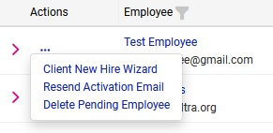
  - Client New Hire Wizard – Only available if the employee has completed the onboarding wizard. Re-directs you to the New Hire Wizard to finalize the onboarding of the employee and complete the hiring process.
  - Resend Activation Email – Sends the onboarding activation e-mail to the employee again.
  - Delete Pending Employee – Stops the onboarding process and removes the employee from the onboarding system.

