Completing the I-9 Form After Onboarding

- Navigate to Employee Admin Tools -> Employee Administration -> I-9 Management -> Form I-9.
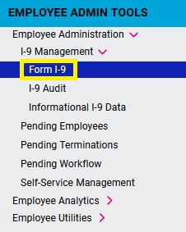
- Select the employee you just hired and then click on the Page 2 Employer & Reverification tab.
- Complete the required fields then click Verify and Sign Form.
