How to Initiate a New Hire in iSolved Onboarding

- Navigate to Employee Admin Tools -> Employee Administration -> Pending Employees.
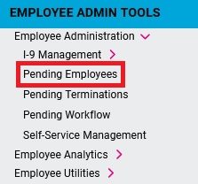
- Click on + Initiate Onboarding
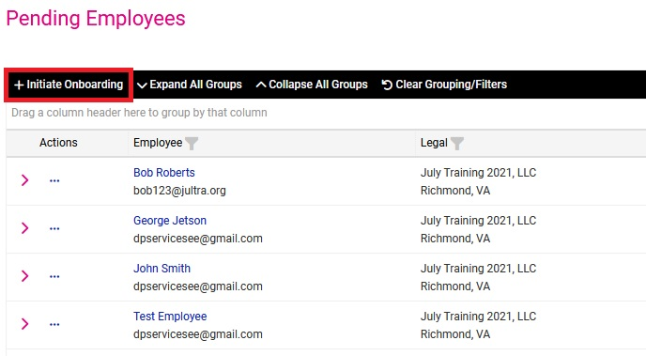
- Fill in the required fields and then click Save.
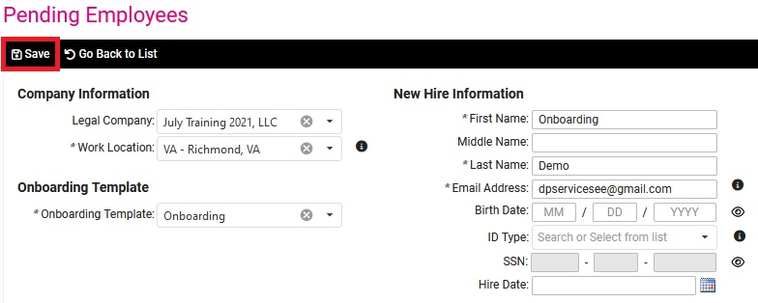
Note: If you enter information in the Birth Date, SSN, or Hire Date fields, the system will generate a warning if those fields match the same fields for an existing employee (active or terminated) to help prevent you from accidentally onboarding an employee that should be a re-hire/re-board.

