Employee Messages

Employee Message have a wide array of uses but the most common are to use them to display messages for employees in their Self-Service or Adaptive login or to utilize them in the Onboarding system.

- Navigate to Client Management -> HR Management -> HR Administration -> Message Categories.
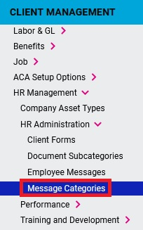
- Click +Add New to add a new Message Category and give it an appropriate Category Heading. Optionally, you can add a Category Description and enter a Display Order to determine the order in which it appears in a future dropdown menu.
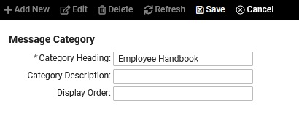
- Next, navigate to Client Management -> HR Management -> HR Administration -> Employee Messages.
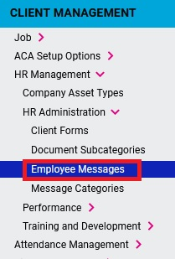
- Click +Add New to add a new message. Title the message appropriately, enter an Effective Date, select a Message Category, and check the box for Legal Company Access. You can also utilize the following options:
  - Expiration Date: Optional but can be used when a specific message should only be displayed for a certain amount of time. A message will be automatically made inactive once the expiration date has passed.
  - Show on Employee Landing Page: If you select this option the message will appear on the Employee Messages screen of ESS. A reminder will appear on the employee’s welcome page upon signing in.
  - Show on Company Information Page: This option will cause the message to appear on the Company Information page.
  - Add Link: Allows you to add a link and set the Link Text that the employee can click on.
  - Add Document: Allows you to upload documents that require employees to open and acknowledge they have read them.
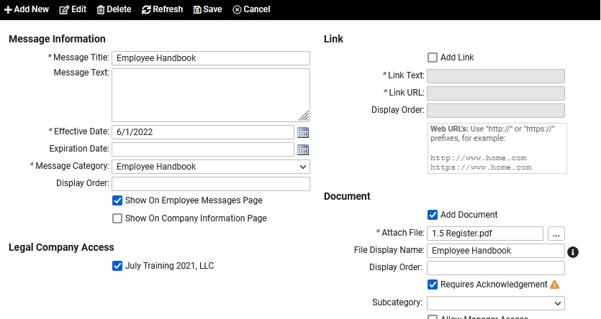
- When done making your selections, click Save.
  - After Saving you also have the ability to add Fillable Forms under the Forms tab to provide documents with fillable fields for the employee to complete.

