Approving/Rejecting Time Off Requests

- Navigate to Employee Self Service -> Time -> Admin Calendar
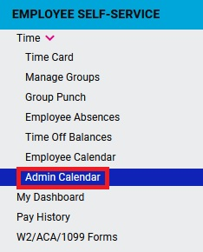
- Click the Pending Requests tab at the top of the screen
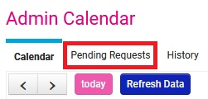
- Select the request from the list that you would like to Approve or Reject by clicking on it.
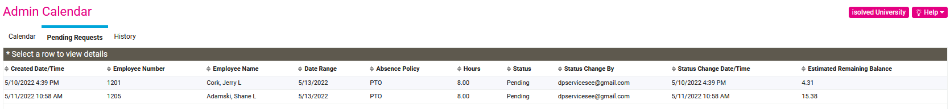
- Select the Workflow Action for Approves or Rejects, then click Process.
